# Phase 2: Innovation

After thorough research and analysis, we arrived at an innovative solution to solve the above problem as detailed in phase 1 of our project.

We will be using the ESP8266node MCU board as well as Arduino UNO microcontroller as both these suit the best for our project

**How does Microphone Module Work?**

The microphone based sound sensor is used to detect sound. It gives a measurement of how loud a sound is. The sound sensor module is a small board that mixes a microphone (50Hz-10kHz) and a few processing circuitry to convert sound waves into electrical signals. This electrical signal is fed to on-board **LM393 High Precision Comparator** to digitize it and is made available at the OUT pin.

The module features a built-in potentiometer for sensitivity adjustment of the OUT signal. We will set a threshold by employing a potentiometer. So that when the amplitude of the sound exceeds the edge value, the module will output LOW, otherwise, HIGH. Apart from this, the module has two LEDs. The facility LED will illuminate when the module is powered. The Status LED will illuminate when the digital output goes LOW.

## Decibel meter with ESP8266 & 0.96” I2C OLED Display

So here is the circuit diagram we have assembled on the breadboard.

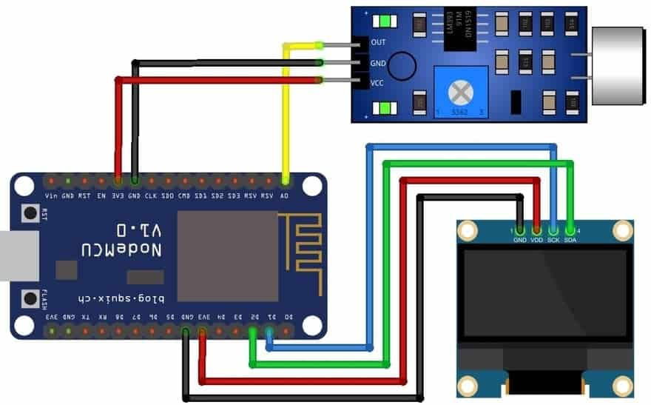

Connect the I2C Pins **(SDA, SCL)** of the OLED Display to **D2 & D1** pins of NodeMCU ESP8266. Supply the OLED Display and sound sensor **VCC**and **GND**pins with **3.3V**and **GND**Pins respectively. Similarly, the sound sensor is interfaced with the analog pin **A0**of NodeMCU **ESP8266**.

So here is the assembly on a breadboard. All the components are assembled as per the circuit diagram.